**LAB EXERCISE – 7**

* RAMAKRISHNAN ILANGHOVAN (23BCE1489)

***1)***

***CODE:***

<!DOCTYPE html>

<html lang="en">

<head>

    <meta charset="UTF-8">

    <meta name="viewport" content="width=device-width, initial-scale=1.0">

    <title>Document</title>

</head>

<body>

    <div style="margin: 25px; border: 6px solid green; padding: 20px; height: 100px; width: 400px; color: #0000ff;">

        <p>

            VIT Chennai is a prestigious private university in Tamil Nadu, known for its academic excellence.

            It offers a wide range of undergraduate and postgraduate programs with a focus on innovation and research.

            The campus provides state-of-the-art infrastructure and a vibrant learning environment.

        </p>

    </div>

</body>

</html>

***OUTPUT:***

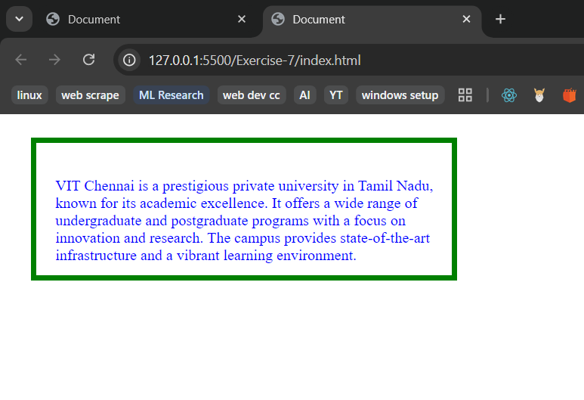

***2)***

***CODE:***

<!DOCTYPE html>

<html>

<head>

</head>

<body>

    <div class="content">

        <h1>Welcome to Pet Paradise</h1>

        <div class="pet-descriptions">

            <p>Dogs are loving companions known for their loyalty and playful nature. They come in various breeds, each with unique characteristics and personalities.</p>

            <p>Cats are independent and graceful pets that make wonderful companions. They are known for their hunting instincts and affectionate behavior.</p>

            <p>Birds bring cheerful songs and vibrant colors to any home. They are intelligent creatures capable of learning tricks and mimicking sounds.</p>

        </div>

        <div class="box">

            <center><svg width="200" height="350" viewBox="0 0 100 100" class="ballbox">

                <circle class="ball" cx="50" cy="50" r="20" fill="red" stroke="black" stroke-width="2"/>

            </svg></center>

            <img src="./image.gif" alt="" class="dog">

        </div>

    </div>

</body>

</html>

.content {

    background-image: url('./bg.png');

    background-position: center;

    background-repeat: no-repeat;

    background-size: cover;

    color:white;

    padding: 20px;

    border-radius: 10px;

    height: 90vh;

}

h1 {

    background-image: linear-gradient(to right, red, orange, yellow, green, blue, indigo, violet);

    background-clip: text;

    color: transparent;

    font-size: 2.5em;

    text-align: center;

    padding: 20px;

}

body {

    font-family: Arial, sans-serif;

    margin: 0;

    padding: 20px;

}

.pet-descriptions {

    column-count: 3;

    column-gap: 40px;

    line-height: 30pt;

    margin: 20px 0;

}

@keyframes *playBall* {

    10% {transform: translateY(30px);}

    20% {transform: translateY(60px)}

    30% {transform: translate(10px,0px);}

    40% {transform: translate(15px,10px);}

    50% {transform: translate(15px,20px);}

    60% {transform: translate(16px,30px);}

    70% {transform: translate(17px,40px);}

    80% {transform: translate(18px,50px);}

    90% {transform: translate(19px,60px);}

    100% {transform: translate(20px,20px);}

}

.ball {

    animation: playBall 3s infinite ease-in;

}

.ballbox{

    margin-left: 300%;

}

.dog{

    margin-left: 50%;

}

.box{

    display: flex;

    flex-wrap: nowrap;

}

***OUTPUT:***

